Liseli Lodge Mongu run by Sister Cathy of CCZ  What the 3 week trip includes!  - Return flights*  - Trip related ground transportation  - Shared accommodations  - All breakfasts and most dinners.  - Many meals prepared and served to us, others we will cook and eat communally. Let’s braai (BBQ).  - 2-day safaris with a sunset cruise.  - Excursion to Victoria Falls,  - Visit a baby elephant nursery.  - Visit Sugar Bush, a Zambian leather and textile project.  - 11 days volunteering on the SEEDS projects in Mongu with ample breaks for our mini excursions.  - NOT INCLUDED-alcohol, single upgrades, additional taxis or meals and discretionary spending.  - Must provide own travel health insurance.  - Flight cancellation insurance is advised.  - *price is not guaranteed and will rise the longer one waits to book. |  |  | Who We Are  About Us  SEEDS, our Registered Canadian Charity # 801572736 RR0001 is building both a sustainable community-based seed bank and a tree nursery to provide critical seeds for home vegetable gardens, implement a local reforestation program, and develop a tree-planting program to support elephants in Zambia Africa.  Contact Us  Join us to help people, the environment and elephants in Zambia, Africa in August 2015  Phone: 647 444-5534  Email: joanne@sendseedstoafrica.org  Web: www.sendseedstoafrica.org  Socio-Economic And Environmental Development Solutions (SEEDS)  4 Browning Ave.,  Toronto, On., M4K 1V7  647 444-5534 |  | 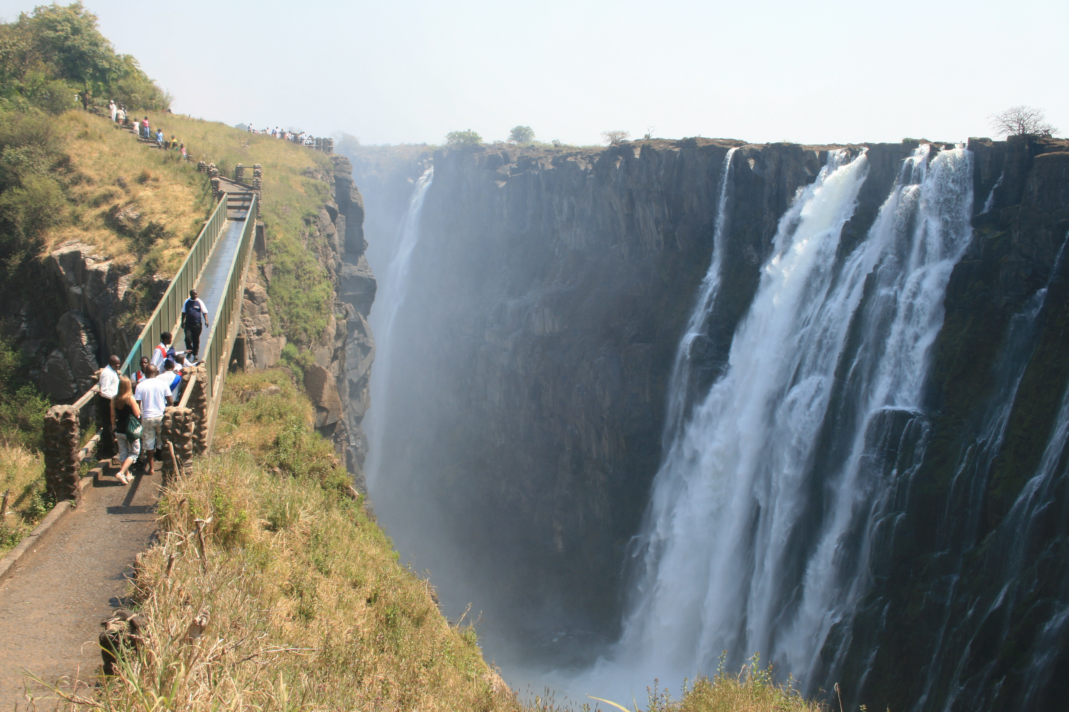 | - Socio-Economic And Environmental Development Solutions (SEEDS)  - “ Voluntourism Trip ”  - Aug. 1st to Aug. 22nd., 2015

Where in Zambia?  This “ voluntourism” trip will start and end in Lusaka, the capital city of Zambia.  After arriving in Lusaka we will stay at Kilimanjaro Country Lodge for two nights with its spacious outdoor patio and beautiful grounds.  After a restful sleep in the most comfortable beds in which you have ever slept, and a full complimentary breakfast, we will go to a baby elephant nursery and then to the Sugar Bush Textile and Leather Facility. Then early to bed as we will be up at 6am to take an air-conditioned bus to Mukambi for the 2-day safari.  We will then catch the bus to Mongu & stay at Liseli Lodge which is run by Sister Cathy of the Catholic Church Of Zambia. Mongu is our home where we will be doing the volunteer work for 11 days and then off to Livingstone to see Victoria Falls for 3 nights.  After Livingstone we will take the bus back to Lusaka, stay overnight and then catch the flight back to Toronto that afternoon. |  |  | The Silozi Seed Bank and Trees for Elephants are the two projects you will be volunteering with.  SEEDS has built a resource garden and tree nursery at our resource centre in Mongu  Some volunteer duties could be:  - plant vegetable seeds in our garden  - paint signs  - build raised garden beds  - dig compost pits  - bring black soil from flood plain  - plant tree seedlings in community  - plant tree seeds in planting bags  - build a fence around nursery  - design & implement projects  - take turns cooking meals  - grocery shop  - teach children & adults  - arrange BBQ night with Farmers  - put screens & windows in our resource centre windows as we don’t any.  - Install floor in resource centre  - teach the children how to plant a vegetable garden  - teach adults how to can fruit & vegetables |  |  | Naomi is one of the best helpers in Mongu!  There are so many ways you could contribute:  - help children practice English.  - read and bring books on gardening/permaculture to share with adults & children.  - save and bring seed catalogues with pictures as a reference.  - plan a craft with children.  - organize an art, music, drama, sports event with local children.  - build counter tops, cupboards for seed storage.  - construct a simple vegetable trellis.  - teach a skill like sewing or knitting.  - Be creative-think of your own contribution.

