. BORE HOLE BOP
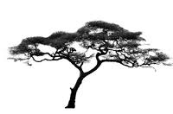

FOR
SEEDS *

www.sendseedstoafrica.org

___________________________________________________________________________________________________

DATE : Saturday, 27 September, 2014
LOCATION: 4 Browning Ave.,Tor., On., M4K 1V7

_____________________________________________________________________________________________________________________________________________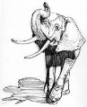
…6:00 COCKTAILS (B.Y.O.B.) 7:00 BUFFET
(B.Y.O.B.)

Assorted Non- GMO organic foods provided
____________________

8:30 ENTERTAINMENT ♫♪ “CHANSA”
& Bob Sheppards band TBA

TICKETS : Donate what you Can!
Tax receipt over $15.00

For Inquiries Kindly Contact
Joanne Hutchinson 647•444•5534

